

**Project Report**

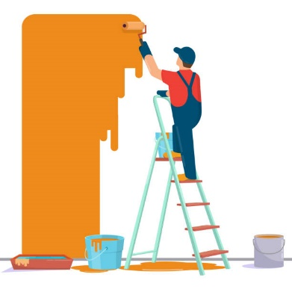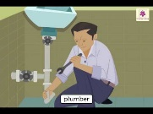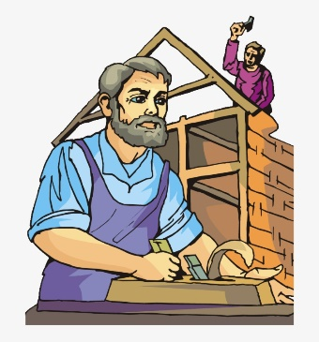

**House Maintainer’s**





Group Members

Umm-e-Aimen Ghouri

&

Aqsa Jawed

1. Definition of the problem

House Maintainer’s are providing service for people who are tired to go shops and finding labours for their any type of problems in houses, shops and cars. They want to host a website with all the information about their organization and various labour service plans available with them.

1. Requirement Analysis

The web site is to be created based on the following requirements.

* This website is consist on three pages.
* First is our home page. And it consist on two sections
* They will ask about your problem and give you suggestions about which labour you want.
* You can also search a labour from who you want to work at your house.
* On last page you can register your self
* Our website also provide classes for peoples who want to learn about these works.
* Our website provide you Intelligent Labours who do their work with honesty and they will sufficient for you. Also they will take less amount for your work.